Game Week Project Guide

Background
Most of you have never built a game before. That's exactly the point.
This week isn't about becoming game developers. It's about proving you can enter completely unfamiliar territory and ship polished, production-quality software using AI as your learning engine.

This project tests your ability to:
- Rapidly acquire expertise in unfamiliar domains using AI
- Make informed technical decisions without prior experience
- Build a methodology for AI-accelerated learning that you can apply anywhere
- Deliver polished results despite starting from zero
We're using game development as the vehicle because:
- It's likely unfamiliar territory for most of you
- Games demand technical excellence - performance issues are immediately visible
- The quality bar is clear - it either feels good to play or it doesn't
- Multiplayer requirements add genuine technical complexity

Core Challenge
You will develop a multiplayer game using technologies you have never worked with before.
This project tests your ability to:
- Research and learn new technologies rapidly using AI
- Make informed technical decisions under time constraints
- Build production-quality software in unfamiliar territory
- Demonstrate that AI-augmented developers can match or exceed traditional development timelines

Technical Requirements
Game Specifications
- Multiplayer Support: Real-time interaction between multiple players
- Performance: Low latency, high performance gameplay with no lag
- Platform: Your choice - mobile, web, or desktop application
- Complexity: Must include levels or character progression - players need a sense of
- advancement
- Engagement: Fun, interesting gameplay with clear objectives or storyline

Development Pathways
Choose one of these pathways based on your target platform. Each pathway has been selected for having excellent documentation, active communities, and AI-friendly learning resources:
Path: Unity for Cross-Platform (https://unity.com/)
- Engine: Unity
- Language: C#
- Networking: Unity Netcode for GameObjects or Mirror Networking
- Platform: Desktop or WebGL build
- Why this path: Unity has the largest game development community, countless tutorials, and comprehensive documentation. C# is well-structured and extensively covered by AI training data.
- Documentation at: docs.unity.com

Development Framework
Phase 1-2: Research and Learning Phase
Objective: Become competent in your chosen tech stack
1. Technology Selection
- Analyze game requirements against available technologies
- Use AI to compare pros/cons of different tech stacks
- Make an informed decision based on project constraints
2. Create Your Learning Path
- Use AI to generate a customized curriculum for your chosen stack
- Focus on essential concepts needed for your game
- Build small proof-of-concept demos to validate understanding
3. Architecture Planning
- Design your game architecture with AI assistance
- Plan networking infrastructure for multiplayer support
- Identify potential performance bottlenecks early

Phase 3-5: Core Development Phase
Objective: Build the fundamental game systems
1. Game Mechanics Implementation
- Start with single-player mechanics
- Use AI to debug and optimize unfamiliar code patterns
- Implement core gameplay loop
2. Multiplayer Integration
- Add networking layer
- Implement state synchronization
- Handle player connections/disconnections
3. Performance Optimization
- Profile and identify bottlenecks
- Use AI to suggest optimization strategies
- Ensure smooth gameplay with multiple concurrent players

Phase 6-7: Polish and Testing Phase
Objective: Create a polished, playable experience
1. Gameplay Enhancement
- Add progression systems or storyline elements
- Implement UI/UX improvements
- Balance game mechanics based on testing
2. Stress Testing
- Test with maximum expected concurrent players
- Verify low-latency performance
- Fix any remaining bugs or issues
3. Documentation
- Create setup and deployment instructions
- Document your learning process and AI utilization
- Prepare demonstration materials

Evaluation Criteria
Your project will be assessed on:
1. Technical Achievement
- Successfully implementing multiplayer functionality
- Meeting performance requirements
- Code quality despite unfamiliar tech stack
2. Learning Velocity & Methodology
- How quickly you became productive in new technologies
- Documentation of your learning tools and resources
- Specific AI prompts and techniques that accelerated learning
- Learning pathway decisions and pivots
3. Game Quality
- Fun factor and engagement
- Implementation of levels or progression system
- Polish and attention to detail
4. AI Utilization
- Strategic use of AI tools for learning
- Problem-solving efficiency with AI assistance
- Innovation in applying AI to development challenges
- Quality of prompts and interactions with AI

Deliverables
1. Working Game
- Deployed and accessible for testing
- Supporting multiple concurrent players
- Meeting all technical requirements
2. GitLab Repository
- Architecture overview
- Setup and deployment guide
- Key technical decisions and rationale
3. Brainlift
- Daily progress updates
- AI prompts and interactions that accelerated learning
- Challenges faced and solutions found
4. Additional Documentation
- Technical walkthrough of key features
- Reflection on AI-augmented development process

Success Metrics
You will have succeeded if you can demonstrate:
- A fully functional multiplayer game in a previously unknown tech stack
- Development velocity comparable to or exceeding traditional methods
- Effective AI utilization throughout the learning and building process
- A fun, engaging game that showcases technical competence

Final Notes
This project simulates real-world scenarios where developers must quickly adapt to new
technologies. Your ability to leverage AI for rapid learning and development is the key
differentiator. Focus on smart decision-making, efficient learning paths, and pragmatic
implementation choices.

Remember: The goal isn't perfection in 7 days—it's demonstrating that AI-augmented
developers can achieve in one week what might traditionally take much longer when facing
unfamiliar technology stacks.

Intended Game Summary:
This will be a multi-player game that will help kids find what they are good at or interested in to help them choose a career path.
The user will have different types of mini games that they can choose from to play. Each time a game is completed successfully the user earns a degree. The number of degrees allows the user to level up. Depending on the types of degrees the person has, it will lead to achieving an ultimate career path and choice.

It would be nice if the path went along with the model below:
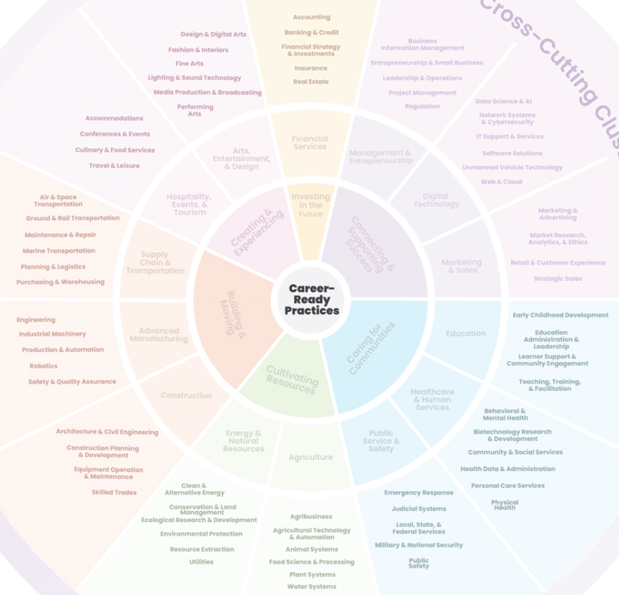

Career Clusters examples could be:
- Advanced Manufacturing
- Construction
- Supply Chain & Transportation
- Arts, Entertainment, & Design
- Hospitality, Events, & Tourism
- Financial Services
- Education
- Healthcare & Human Services
- Public Service & Safety
- Agriculture
- Energy & Natural Resources
- Digital Technology
- Marketing & Sales
- Management & Entrepreneurship

I would like to begin with a few basic games that will end with at least the following 5 career paths that lead to the following jobs:
- Doctor
- Lawyer
- AI Engineer (Technology)
- Artist (music, painter)
- Architect (construction)

The mini games should be basic games that are enjoyable for children.

There will be 3 different mini game levels. Each level will have multiple mini games and completing the short game will help get the user closer to their recommended career.

The game environment should be a child that is walking to different areas/schools to play the mini game. The types of mini games achieved will lead to the childs career. Each school will have its own set of games that lead to the career path.

I would like multiple child avatars (minimum 4) of different races and genders to choose from for the character. Eventually, after we implement single player mode, we will implement multi-player mode.

